An Investigation of the Effectiveness of Open Source Web Application Firewalls
Academic Project Report
Target application | DVWA
WAFs evaluated | ModSecurity + OWASP CRS; NAXSI
Attack/scanning tool | OWASP ZAP
Automation | Python script controlling ZAP through the ZAP API
Evidence rule | No unprovided result values are invented; missing values are marked as not available/to be collected.

1. Executive Summary
This project investigates the effectiveness of open-source Web Application Firewalls (WAFs) in detecting, blocking, and classifying web application attacks. The target application used for testing was Damn Vulnerable Web Application (DVWA), hosted on an Ubuntu virtual machine. Attack traffic was generated from a Kali Linux attacker virtual machine using OWASP ZAP, with additional automation implemented through a Python script that controlled ZAP via the ZAP API.
The WAF technologies selected for evaluation were ModSecurity with the OWASP Core Rule Set (CRS), and NAXSI deployed through Nginx. The methodology was designed to compare the exposed attack surface of DVWA without WAF protection against the behaviour of DVWA when protected by each WAF. The project therefore focuses not only on whether attacks are blocked, but also on whether blocking can be measured consistently across attack categories.
Evidence from screenshots/logs shows that:

Evidence area | Finding from provided evidence
ZAP manual scan | A ZAP scan against http://192.168.56.20/DVWA/ completed and showed 4,026 requests and 276 new alerts in the ZAP GUI.
ZAP HTML report | The generated ZAP report recorded 29 alert categories across High, Medium, Low, and Informational risk levels.
Python/ZAP automation | The automation framework created fresh ZAP sessions, ran spider and active scans, collected request/response history, collected alerts, and exported CSV files.
Baseline-labelled automation run | 1,732 total ZAP requests were recorded, with 1,654 allowed, 4 blocked, 70 client errors, 0 server errors, and 91 alerts.
ModSecurity automation run | 1,731 total ZAP requests were recorded, with 1,007 allowed, 678 blocked, 43 client errors, 0 server errors, and 103 alerts.
ModSecurity per-attack results | SQL injection, path traversal/file inclusion, file upload, and forced browsing/directory discovery were blocked at very high rates in the provided ModSecurity classification screenshot.
ModSecurity logs | Apache access log and ModSecurity audit log screenshots show HTTP 403 responses and CRS audit warnings during testing.
NAXSI results | NAXSI comparative result values were not available in the provided artifacts and should be collected before final comparative conclusions are made.

The strongest supported finding is that ModSecurity with OWASP CRS blocked a significant proportion of attack traffic generated by ZAP, especially SQL injection and file/path-related attack categories. However, the evidence also shows that some attack-like traffic was allowed, particularly user-agent/header fuzzing and brute-force/authentication attempts. These findings should be interpreted cautiously because HTTP response codes are useful indicators of blocking, but they do not fully prove rule-level WAF detection without corresponding WAF audit logs.

2. Introduction
A Web Application Firewall is a security control placed in front of a web application to inspect HTTP traffic and identify malicious patterns before they reach the application. WAFs commonly detect attacks such as SQL injection, cross-site scripting, path traversal, remote file inclusion, command injection, protocol abuse, and suspicious request headers. Unlike a network firewall, which primarily filters traffic by network-level attributes such as IP address, port, and protocol, a WAF operates at the application layer and evaluates the contents and structure of web requests.
Open-source WAFs are important because they provide accessible security controls for students, researchers, small organisations, and administrators who may not have access to commercial WAF products. However, the effectiveness of a WAF depends heavily on its configuration, rule set, deployment mode, tuning, and the type of traffic being tested. Therefore, open-source WAF evaluation should be empirical rather than purely descriptive.
DVWA was selected because it is a deliberately vulnerable web application designed for controlled security testing. It provides vulnerable modules such as SQL injection, command execution, file inclusion, file upload, cross-site scripting, brute force, and weak session/security behaviours. This makes it suitable for observing how WAFs respond to vulnerable application endpoints in a legal lab environment.
OWASP ZAP was selected because it is an open-source dynamic application security testing tool that can spider an application, perform active scans, generate alerts, and expose an API for automation. In this project, ZAP was used both through its graphical interface and through a Python automation framework. This allowed manual observation as well as repeatable collection of request, response, status-code, and alert data.

3. Supervisor Feedback and Methodology Adjustment
The project methodology shifted from simple WAF installation and basic scanning toward a more empirical evaluation of WAF effectiveness. This adjustment is important because merely proving that a WAF was installed does not demonstrate whether it blocks attacks, misses attacks, or incorrectly blocks normal user traffic.
The adjusted methodology focuses on:

Methodology area | Adjustment made
Attack traffic generation | OWASP ZAP spidering and active scanning were used to generate repeatable attack traffic against DVWA.
WAF blocking measurement | HTTP response codes, especially 403, 406, and 501, were used by the automation script as initial indicators of blocking.
WAF comparison | The project was extended to compare ModSecurity with OWASP CRS against NAXSI.
Per-attack category analysis | The Python framework was extended to classify traffic into categories such as SQL injection, brute force/authentication, path traversal/file inclusion, and user-agent/header fuzzing.
Normal versus attack traffic | The methodology was expanded to consider normal user browsing traffic as well as malicious traffic.
False positives and false negatives | The evaluation now considers whether legitimate requests are blocked and whether attack requests are allowed.

Evidence from screenshot/log: the planning screenshots show a transition from the ModSecurity test to a NAXSI-protected test using the same attacks, and explicitly state that the comparison should be between ModSecurity and NAXSI using the exact same attacks.

4. Test Environment
The project environment consisted of two virtual machines:

Component | Description | Evidence status
Kali attacker machine | Used to run OWASP ZAP and the Python automation framework. | Available from ZAP and terminal screenshots.
Ubuntu DVWA/WAF machine | Hosted DVWA and the WAF layer. | Available from Ubuntu terminal screenshots.
DVWA | Target vulnerable web application. DVWA was tested at security level Low according to the project context and cookie evidence showing security=low. | Available from project context and ModSecurity log screenshot.
Apache + ModSecurity + OWASP CRS | Used as the ModSecurity WAF deployment. The audit log screenshot shows ModSecurity for Apache and OWASP CRS were active. | Available from ModSecurity audit log screenshot.
Nginx + NAXSI | Intended second WAF deployment through an Nginx reverse proxy. | Configuration/result evidence not fully available in the provided artifacts.
OWASP ZAP | Used for spidering, active scanning, alert generation, and API-based automation. ZAP version 2.17.0 is shown in screenshots. | Available.
Python automation framework | Controlled ZAP through the API, collected messages and alerts, classified response codes, and exported CSV results. | Available from script text and screenshots.

Network Flow Diagrams
General WAF testing model:
Kali / OWASP ZAP -> WAF layer -> DVWA

ModSecurity deployment model:
Kali / OWASP ZAP -> Apache + ModSecurity + OWASP CRS -> DVWA

NAXSI deployment model:
Kali / OWASP ZAP -> Nginx + NAXSI -> Apache / DVWA

5. Implementation Details

DVWA Setup and Security Level
DVWA was used as the vulnerable target application. The project methodology set DVWA security to Low so that the application would expose vulnerable behaviour suitable for WAF evaluation. Evidence from the ModSecurity audit log screenshot shows a request cookie containing security=low, supporting that DVWA was operating at the intended low security level during at least part of the ModSecurity test.
Earlier testing may have been affected by DVWA being set to Impossible. This is important because DVWA's Impossible level includes stronger application-side protections, which can reduce visible vulnerabilities and make WAF effectiveness difficult to distinguish from application-level defence.

ModSecurity Enabling and Disabling
The screenshots show ModSecurity being enabled using:
sudo a2enmod security2
sudo systemctl restart apache2
sudo systemctl stop nginx

The screenshots also show ModSecurity being disabled using:
sudo a2dismod security2
sudo systemctl restart apache2

This supports the methodology of isolating ModSecurity tests from other WAF layers. In the evidence screenshot, Apache also reports that the security2 module was disabled after a2dismod security2, although Apache required a restart for the new configuration to take effect.

OWASP CRS Validation
The ModSecurity audit log screenshot shows OWASP CRS activity. The visible log entry includes CRS rule metadata such as:

Observed item | Value shown in evidence
Rule file | REQUEST-920-PROTOCOL-ENFORCEMENT.conf
Rule ID | 920350
Message | Host header is a numeric IP address
CRS version | OWASP_CRS/3.3.7
ModSecurity version | ModSecurity for Apache/2.9.12
Engine mode | ENABLED

This screenshot demonstrates that ModSecurity and OWASP CRS were inspecting traffic and producing audit telemetry during the test.

NAXSI Installation and Configuration
The project context states that NAXSI was tested using Nginx as a reverse proxy in front of Apache/DVWA. The planning screenshot also shows the intended NAXSI test sequence:
sudo a2dismod security2
sudo systemctl restart apache2
sudo systemctl start nginx

However, no NAXSI-specific configuration file, NAXSI log output, or NAXSI numerical block-rate result was available in the provided artifacts. Therefore, NAXSI implementation is documented as part of the intended environment, but NAXSI effectiveness results are marked as not available/to be collected.

OWASP ZAP Setup
OWASP ZAP was used in both GUI and API modes. The GUI screenshots show an automated scan against:
http://192.168.56.20/DVWA/

The ZAP API screenshots show ZAP running in daemon mode:
zaproxy -daemon -host 127.0.0.1 -port 8080 -config api.disablekey=true

The API version check returned:
{"version":"2.17.0"}

This confirms that the automation framework was interacting with OWASP ZAP 2.17.0 through the local API service.

ZAP Context and Active Scanning
The ZAP GUI screenshots show the DVWA target in the Sites tree and the active scan interface running against http://192.168.56.20/DVWA/. One screenshot shows the scan in progress, while another shows the scan completed with a populated alerts tree.
The ZAP GUI evidence also shows:

ZAP GUI item | Value shown
Target URL | http://192.168.56.20/DVWA/
ZAP version | 2.17.0
Scan status | Completed in the relevant screenshot
Number of requests | 4,026
New alerts | 276
Alert categories shown | 29

The 4,026 request count comes from the ZAP GUI/manual scan evidence and should not be merged with the separate Python automation result totals unless the same test run can be confirmed.

Python Script Controlling ZAP API
The provided Python script controlled ZAP using HTTP API calls to:

Function | Purpose
new_session() | Creates a fresh ZAP session for each test mode.
spider_scan() | Starts a traditional ZAP spider scan and waits until it reaches 100%.
active_scan() | Starts a ZAP active scan and waits until it reaches 100%.
get_alerts() | Collects ZAP alerts using the core alerts API endpoint.
get_messages() | Collects request/response history using the ZAP messages API endpoint.
extract_status_code() | Extracts HTTP response status codes from ZAP response headers.
classify_response() | Classifies responses as blocked, allowed, client error, server error, unknown, or other.
summarize() | Calculates request totals, block rates, allowed rates, status-code breakdowns, and alert-type counts.
save_csv() | Exports the results into CSV format.

The script classified 403, 406, and 501 as blocked responses. Responses in the 2xx and 3xx range were classified as allowed. Other 4xx responses were classified as client errors, and 5xx responses were classified as server errors.

CSV Result Generation
The automation screenshots show CSV outputs being saved, including:
results/modsecurity_summary.csv
results/modsecurity_attack_breakdown.csv
results/modsecurity_all_zap_messages.csv
results/modsecurity_zap_alerts.csv

The CSV files themselves were not present in the provided folder listing, but the screenshots prove that the script generated them during execution.

6. Testing Methodology

Phase 1: Baseline
The baseline phase tested DVWA with security set to Low and the WAF disabled. ZAP spidering and active scanning were used to measure vulnerabilities and responses without WAF protection. The purpose of this phase was to create a comparison point showing how DVWA behaves when exposed directly to automated scanning.
Evidence status: baseline-labelled automation screenshot available. The screenshot filename and context indicate baseline testing, but the console output still shows mode: modsecurity. This should be corrected or verified before final submission.

Phase 2: ModSecurity
The ModSecurity phase tested DVWA with security set to Low and Apache ModSecurity enabled with OWASP CRS. The same ZAP scan pattern was repeated using the Python automation framework. The purpose was to measure whether ModSecurity blocked, allowed, or logged attack traffic.
Evidence status: ModSecurity automation result screenshot, ModSecurity classification screenshot, and ModSecurity audit/access log screenshots are available.

Phase 3: NAXSI
The NAXSI phase was intended to disable ModSecurity, enable Nginx/NAXSI as a reverse proxy, and repeat the same ZAP scanning methodology. The purpose was to compare a second open-source WAF against ModSecurity using equivalent attack traffic.
Evidence status: NAXSI result values are not available in the provided artifacts. The report therefore does not claim measured NAXSI effectiveness.

Phase 4: Planned Extension
The planned extension involves:

Extension | Purpose
Individual attack-category testing | Test SQLi, XSS, path traversal, command injection, brute force, file upload, and forced browsing separately.
Normal traffic generation | Measure whether ordinary browsing, login, navigation, and form submission are blocked.
False positive analysis | Identify legitimate requests incorrectly blocked by the WAF.
False negative analysis | Identify attack requests allowed by the WAF.
Classification accuracy | Compare WAF logs against known attack labels to determine whether the WAF correctly classified attacks.

7. Evidence From Screenshots

Figure | Screenshot/log evidence | What the evidence proves | How it supports the methodology or results
Figure 1 | ZAP on DVWA Security Low NAXII NGINX/ZAP Vunerable scans.png | OWASP ZAP 2.17.0 was used to actively scan http://192.168.56.20/DVWA/. | Supports the use of ZAP as the attack/scanning tool and shows the target URL.
Figure 2 | ZAP on DVWA Security Low NAXII NGINX/Site Tree.png | ZAP completed a scan with 4,026 requests and 276 new alerts in the GUI. | Supports that ZAP generated substantial traffic against DVWA.
Figure 3 | ZAP on DVWA Security Low NAXII NGINX/Site Tree Shows Vunerabilities.png | ZAP displayed 29 alert categories after scan completion. | Supports the vulnerability discovery baseline and alert-category analysis.
Figure 4 | ZAP on DVWA Security Low NAXII NGINX/Alerts.png | ZAP alert categories included Path Traversal, Remote File Inclusion, Anti-CSRF issues, Application Error Disclosure, CSP issues, Directory Browsing, and others. | Supports the claim that the scan covered multiple vulnerability classes.
Figure 5 | Python Automation/ZAP in API Mode.png | ZAP was launched in daemon/API mode using 127.0.0.1:8080 and API key disabling for local automation. | Supports the automation implementation.
Figure 6 | Python Automation/zap api.png | The ZAP API version endpoint returned 2.17.0. | Confirms that the Python automation communicated with ZAP through the API.
Figure 7 | Python Automation/Classify Attacks/Python Baseline.png | The baseline-labelled run recorded 1,732 requests, 1,654 allowed, 4 blocked, 70 client errors, 0 server errors, and 91 alerts. | Supports baseline measurement, with caveat that the console mode label still reads modsecurity.
Figure 8 | Python Automation/Modsecurity Result after classification.png | The ModSecurity run recorded 1,731 requests, 1,007 allowed, 678 blocked, 43 client errors, 0 server errors, and 103 alerts. | Supports ModSecurity blocking measurement and per-attack category analysis.
Figure 9 | Python Automation/Python Automation Result.png | A ModSecurity automation run produced a status-code breakdown including 403: 679, 404: 43, 301: 135, 302: 99, and 200: 771. | Supports response-code based classification, while showing that separate runs may have minor count differences.
Figure 10 | Mod Sec Security Low,/Live Blocking.png | ModSecurity audit logs showed OWASP CRS rule activity and engine mode enabled. | Supports that ModSecurity/CRS was actively inspecting traffic.
Figure 11 | Mod Sec Security Low,/Total Allowed, Blocked ModSec WAF Low.png | Apache access log counters showed 3,483 log lines, 932 403 responses, 1,205 200 responses, and 18,030 ModSecurity audit warnings. | Supports WAF blocking/logging evidence from server-side logs.
Figure 12 | Mod Sec Security Low,/need to continue from her.png | The methodology included enabling ModSecurity for one test and disabling it before the NAXSI test. | Supports the comparative test design.
Figure 13 | Continue from this.png | The planned next stage was a NAXSI-protected test comparing ModSecurity and NAXSI using the same attacks. | Supports the methodology adjustment toward comparative WAF evaluation.

Embedded Screenshot Evidence
The following figures are embedded from the provided screenshot evidence. Each caption states what the screenshot demonstrates and how it supports the methodology or results.
Figure 1: OWASP ZAP active scan against DVWA
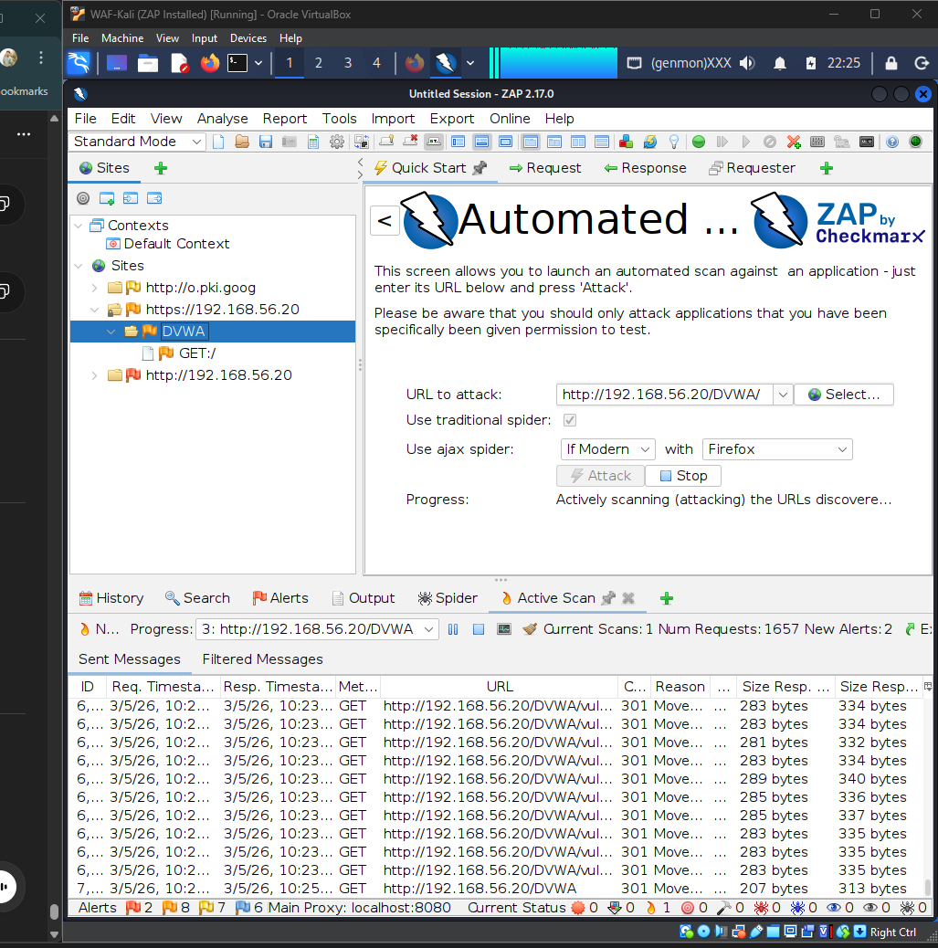
Evidence from screenshot/log: This screenshot shows OWASP ZAP 2.17.0 actively scanning http://192.168.56.20/DVWA/.
Methodological support: It supports the use of ZAP as the attack generation and scanning tool.
Figure 2: ZAP site tree and completed request count
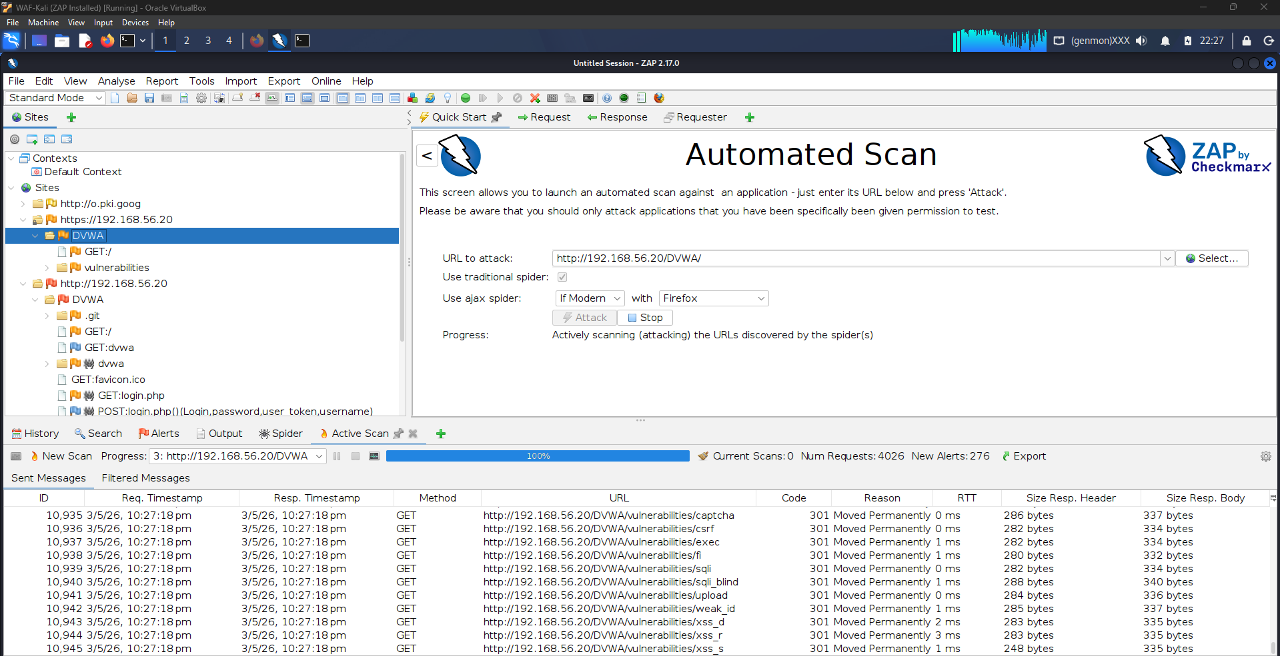
Evidence from screenshot/log: This screenshot shows the DVWA target in the ZAP Sites tree, 4,026 requests, and 276 new alerts.
Methodological support: It supports that ZAP generated substantial scan traffic against DVWA.
Figure 3: ZAP alert categories after scan completion
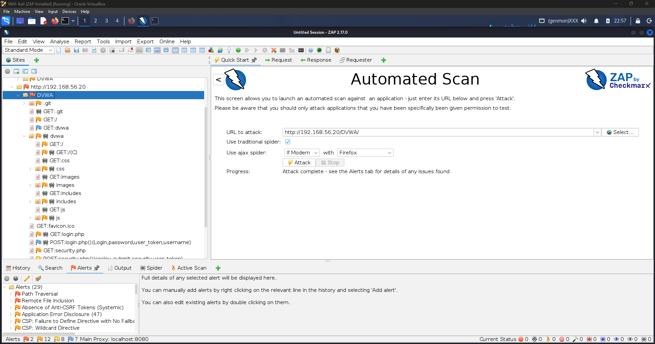
Evidence from screenshot/log: This screenshot shows 29 alert categories in the ZAP Alerts tab after the scan.
Methodological support: It supports the vulnerability discovery and alert-category evidence used in the report.
Figure 4: ZAP Alerts tab showing discovered vulnerability classes
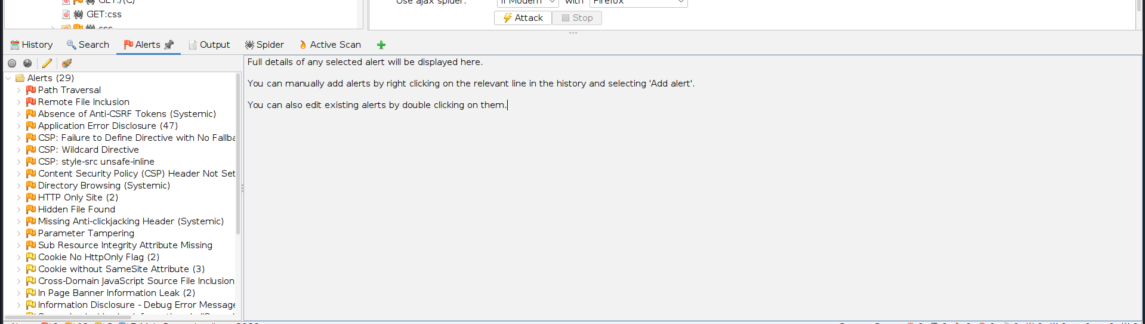
Evidence from screenshot/log: This screenshot shows alert names such as Path Traversal, Remote File Inclusion, Anti-CSRF issues, Application Error Disclosure, CSP issues, and Directory Browsing.
Methodological support: It supports the claim that the scan covered multiple web vulnerability classes.
Figure 5: OWASP ZAP running in daemon/API mode
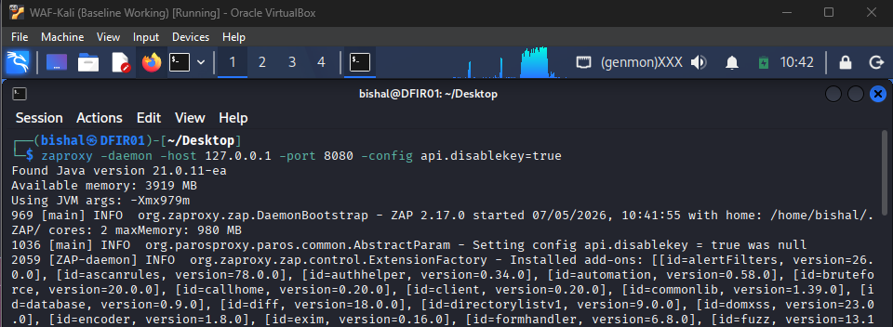
Evidence from screenshot/log: This screenshot shows ZAP launched in daemon mode on 127.0.0.1:8080 with API key disabling for local automation.
Methodological support: It supports the automation approach using the ZAP API.
Figure 6: ZAP API version validation
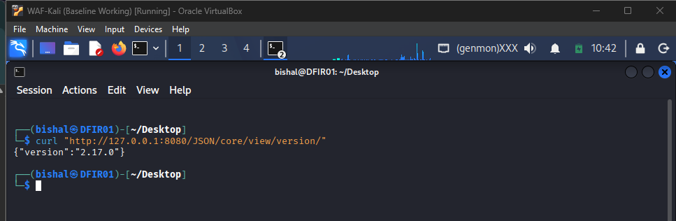
Evidence from screenshot/log: This screenshot shows a curl request to the ZAP API version endpoint returning version 2.17.0.
Methodological support: It confirms that the Python automation could communicate with ZAP through the API.
Figure 7: Baseline-labelled Python automation results
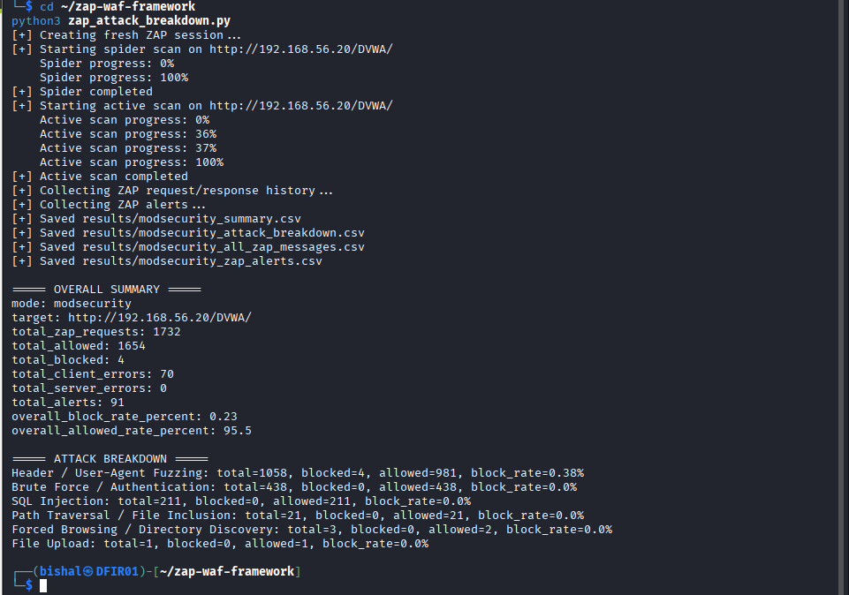
Evidence from screenshot/log: This screenshot records 1,732 total requests, 1,654 allowed requests, 4 blocked requests, 70 client errors, 0 server errors, and 91 alerts.
Methodological support: It supports the baseline-labelled measurement, with the caveat that the console still displays mode: modsecurity.
Figure 8: ModSecurity classified attack breakdown
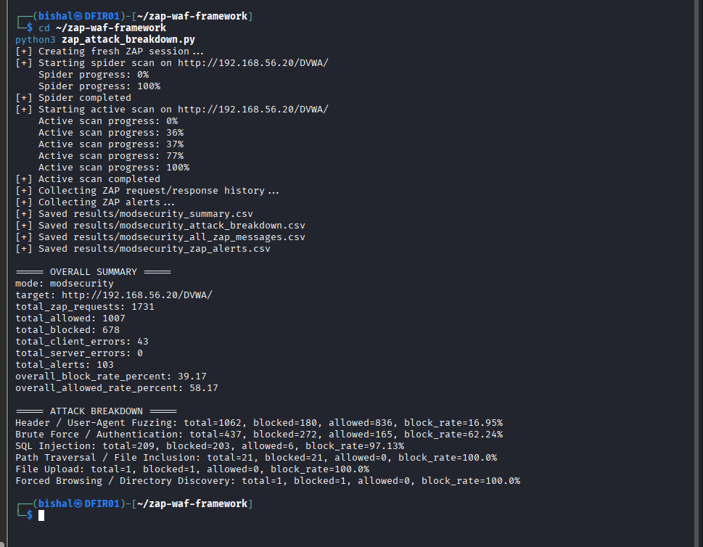
Evidence from screenshot/log: This screenshot records 1,731 requests, 1,007 allowed requests, 678 blocked requests, 43 client errors, 0 server errors, 103 alerts, and per-attack block rates.
Methodological support: It supports the ModSecurity block-rate and per-attack analysis.
Figure 9: ModSecurity automation status-code breakdown
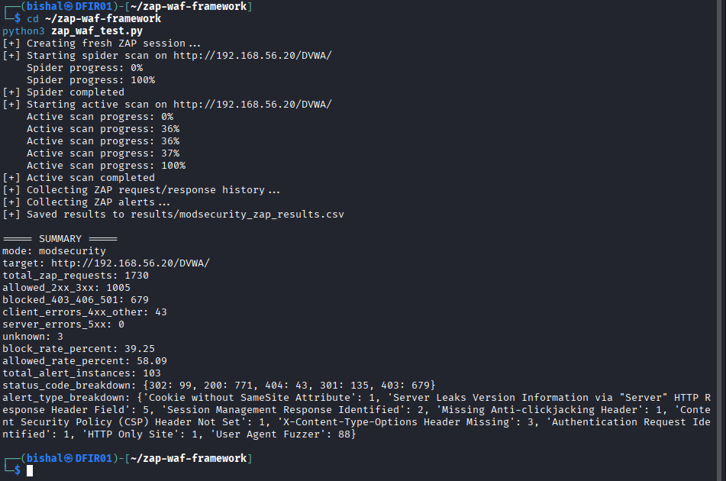
Evidence from screenshot/log: This screenshot shows a ModSecurity run with response status counts including 403, 404, 301, 302, and 200 responses.
Methodological support: It supports the response-code based classification approach used by the automation.
Figure 10: ModSecurity audit log showing CRS rule activity
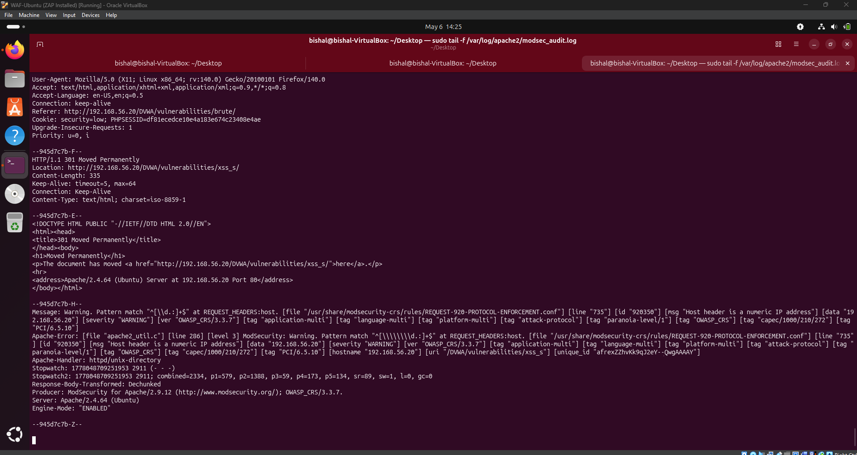
Evidence from screenshot/log: This screenshot shows ModSecurity audit output, OWASP CRS metadata, rule ID 920350, CRS version 3.3.7, and engine mode enabled.
Methodological support: It supports that ModSecurity and OWASP CRS were actively inspecting requests.
Figure 11: Apache and ModSecurity server-side counters
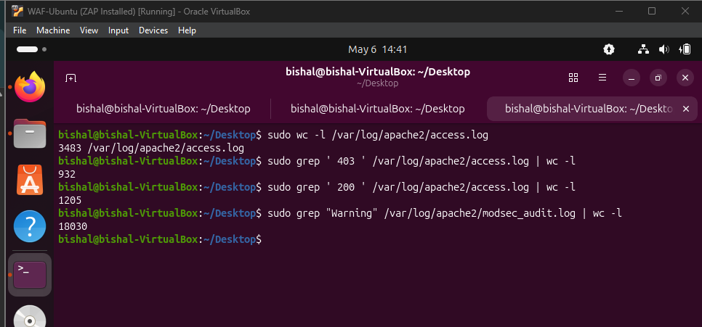
Evidence from screenshot/log: This screenshot shows access log and audit log counts, including 3,483 access log lines, 932 403 responses, 1,205 200 responses, and 18,030 audit warnings.
Methodological support: It supports server-side corroboration of blocking and WAF telemetry.
Figure 12: Methodology note for ModSecurity and NAXSI testing
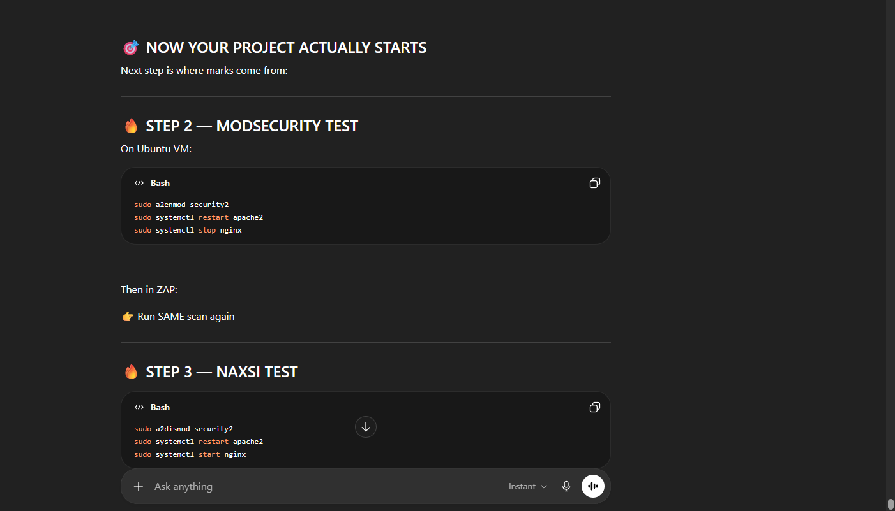
Evidence from screenshot/log: This screenshot shows the planned test sequence for enabling ModSecurity and then moving to the NAXSI test.
Methodological support: It supports the adjusted methodology and comparative test design.
Figure 13: Planned NAXSI-protected comparison
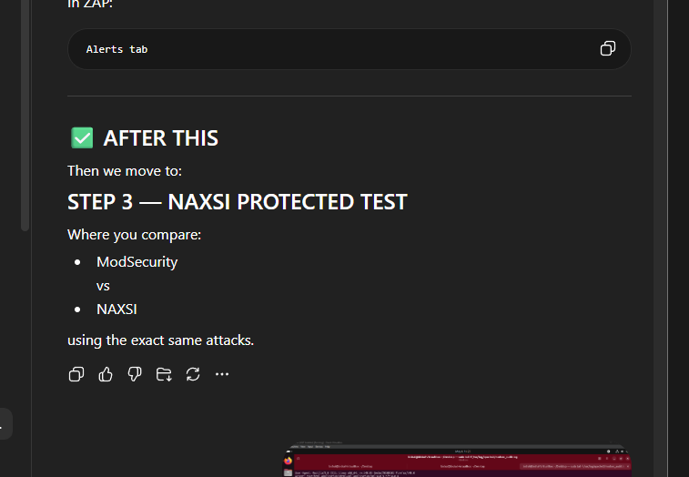
Evidence from screenshot/log: This screenshot shows the next stage as a NAXSI-protected test comparing ModSecurity and NAXSI using the same attacks.
Methodological support: It supports the future comparative evaluation direction.

8. Results

8.1 Baseline Scan Results
The following table uses the baseline-labelled Python automation screenshot. Because the screenshot console still shows mode: modsecurity, this row should be treated as baseline-labelled evidence requiring final verification.

Test mode | Target URL | Total ZAP requests | Allowed requests | Blocked requests | Client errors | Server errors | Total alerts | Block rate %
Baseline-labelled run | http://192.168.56.20/DVWA/ | 1,732 | 1,654 | 4 | 70 | 0 | 91 | 0.23

8.2 ModSecurity Scan Results

Test mode | Target URL | Total ZAP requests | Allowed requests | Blocked requests | Client errors | Server errors | Total alerts | Block rate %
ModSecurity + OWASP CRS | http://192.168.56.20/DVWA/ | 1,731 | 1,007 | 678 | 43 | 0 | 103 | 39.17

8.3 NAXSI Scan Results

Test mode | Target URL | Total ZAP requests | Allowed requests | Blocked requests | Client errors | Server errors | Total alerts | Block rate %
NAXSI + Nginx reverse proxy | Not available/to be collected | Not available | Not available | Not available | Not available | Not available | Not available | Not available

8.4 ModSecurity Per-Attack Breakdown
The following table is based on the ModSecurity classification screenshot.

Attack type | Total attempts | Blocked | Allowed | Client errors | Server errors | Block rate %
Header / User-Agent Fuzzing | 1,062 | 180 | 836 | Not available | Not available | 16.95
Brute Force / Authentication | 437 | 272 | 165 | Not available | Not available | 62.24
SQL Injection | 209 | 203 | 6 | Not available | Not available | 97.13
Path Traversal / File Inclusion | 21 | 21 | 0 | Not available | Not available | 100.00
File Upload | 1 | 1 | 0 | Not available | Not available | 100.00
Forced Browsing / Directory Discovery | 1 | 1 | 0 | Not available | Not available | 100.00

8.5 Baseline-Labelled Per-Attack Breakdown
The following table is based on the baseline-labelled classification screenshot. As noted earlier, the screenshot still displays mode: modsecurity, so this should be verified before final assessment.

Attack type | Total attempts | Blocked | Allowed | Client errors | Server errors | Block rate %
Header / User-Agent Fuzzing | 1,058 | 4 | 981 | Not available | Not available | 0.38
Brute Force / Authentication | 438 | 0 | 438 | Not available | Not available | 0.00
SQL Injection | 211 | 0 | 211 | Not available | Not available | 0.00
Path Traversal / File Inclusion | 21 | 0 | 21 | Not available | Not available | 0.00
Forced Browsing / Directory Discovery | 3 | 0 | 2 | Not available | Not available | 0.00
File Upload | 1 | 0 | 1 | Not available | Not available | 0.00

8.6 ZAP HTML Report Risk Summary
The generated ZAP HTML report recorded 29 alert categories across the following risk/confidence distribution:

Risk level | User Confirmed | High confidence | Medium confidence | Low confidence | Total
High | 0 | 0 | 2 | 0 | 2
Medium | 0 | 6 | 4 | 2 | 12
Low | 0 | 2 | 5 | 1 | 8
Informational | 0 | 1 | 4 | 2 | 7
Total | 0 | 9 | 15 | 5 | 29

8.7 ZAP HTML Report Alert-Type Evidence
The ZAP HTML report included the following alert types. The report's alert-type table contains per-alert instance counts, while the risk-confidence table records 29 alert categories. Because these two totals represent different report views, they should not be forced into a single total without further validation.

Alert type | Risk | Count shown in report
Path Traversal | High | 1
Remote File Inclusion | High | 1
Absence of Anti-CSRF Tokens | Medium | 5
Application Error Disclosure | Medium | 47
CSP: Failure to Define Directive with No Fallback | Medium | 1
CSP: Wildcard Directive | Medium | 1
CSP: style-src unsafe-inline | Medium | 1
Content Security Policy Header Not Set | Medium | 5
Directory Browsing | Medium | 10
HTTP Only Site | Medium | 2
Hidden File Found | Medium | 1
Missing Anti-clickjacking Header | Medium | 5
Parameter Tampering | Medium | 1
Sub Resource Integrity Attribute Missing | Medium | 1
Cookie No HttpOnly Flag | Low | 2
Cookie without SameSite Attribute | Low | 3
Cross-Domain JavaScript Source File Inclusion | Low | 1
In Page Banner Information Leak | Low | 2
Information Disclosure - Debug Error Messages | Low | 1
Server Leaks Version Information via Server HTTP Response Header Field | Low | 7
Timestamp Disclosure - Unix | Low | 5
X-Content-Type-Options Header Missing | Low | 7
Authentication Request Identified | Informational | 1
Content-Type Header Missing | Informational | 5
Cookie Poisoning | Informational | 1
Information Disclosure - Suspicious Comments | Informational | 1
Modern Web Application | Informational | 5
Session Management Response Identified | Informational | 3
User Agent Fuzzer | Informational | 5

8.8 Server-Side ModSecurity Log Evidence
The following values are taken from the ModSecurity/Apache terminal screenshot. These counts should be treated as server-side corroborating evidence, not automatically merged with the ZAP API run totals, because the log window may include traffic outside the exact automation run.

Command/evidence | Count shown
Total Apache access log lines | 3,483
Apache access log entries containing HTTP 403 | 932
Apache access log entries containing HTTP 200 | 1,205
ModSecurity audit log entries containing Warning | 18,030

9. Analysis

9.1 Whether the WAF Blocked Attack Traffic
The ModSecurity classification result shows that ModSecurity with OWASP CRS blocked 678 out of 1,731 ZAP requests, producing an overall block rate of 39.17%. This indicates that ModSecurity was not merely installed passively; it actively blocked a substantial portion of the generated traffic.
The server-side Apache/ModSecurity screenshot further supports this because it shows 932 403 responses in the Apache access log and 18,030 warning entries in the ModSecurity audit log. Evidence from screenshot/log therefore supports the conclusion that ModSecurity was active and producing both blocking responses and audit telemetry.

9.2 Which Attack Types Were Blocked Most Effectively
The strongest ModSecurity results were observed for:

Attack type | Block rate %
Path Traversal / File Inclusion | 100.00
File Upload | 100.00
Forced Browsing / Directory Discovery | 100.00
SQL Injection | 97.13

These results suggest that OWASP CRS was highly effective against the specific SQL injection and file/path-related payloads generated in the provided test run. However, the file upload and forced browsing categories had only one attempt each in the screenshot, so their 100% block rates should not be overgeneralised.

9.3 Whether Any Traffic Was Allowed
The ModSecurity run allowed 1,007 requests. In the per-attack breakdown, the largest allowed counts were:

Attack category | Allowed requests
Header / User-Agent Fuzzing | 836
Brute Force / Authentication | 165
SQL Injection | 6

Allowed traffic does not automatically mean the WAF failed. Some allowed requests may be harmless spidering requests, redirects, login flows, static asset requests, or payloads that did not match CRS blocking rules. However, for attack-labelled traffic, allowed requests should be investigated using both ZAP message history and WAF logs to determine whether they represent false negatives.

9.4 Whether Baseline Results Behaved as Expected
The baseline-labelled run showed a very low block rate of 0.23%, compared with 39.17% for ModSecurity. This is consistent with the expectation that a WAF-disabled baseline should allow most traffic.
However, the screenshot still prints mode: modsecurity, which means the experiment label or script variable may not have been changed for that run. The data should therefore be verified before being used as final baseline evidence. The low blocking rate supports the baseline interpretation, but the label mismatch should be corrected to avoid ambiguity.

9.5 DVWA Security Level and Earlier Results
DVWA security level affects the interpretation of results. At Low security, DVWA exposes vulnerabilities and allows ZAP to generate meaningful attack responses. At Impossible security, DVWA applies application-side defences that may prevent vulnerabilities from being triggered. If earlier scans were conducted with DVWA set to Impossible, the results may reflect DVWA's internal protections rather than WAF effectiveness.
Evidence from screenshot/log shows security=low in the ModSecurity audit log cookie, supporting that at least the ModSecurity audit evidence was collected while DVWA was in Low mode.

9.6 How ModSecurity CRS Categorized Attacks
The ModSecurity audit log screenshot shows CRS rule metadata for protocol enforcement. The visible rule was:

Field | Value
Rule ID | 920350
Message | Host header is a numeric IP address
Rule file | REQUEST-920-PROTOCOL-ENFORCEMENT.conf
Severity | Warning
CRS version | OWASP_CRS/3.3.7

This demonstrates CRS rule-level categorisation, but it does not alone prove classification accuracy for every attack category. Rule-level classification for SQL injection, file inclusion, brute force, and other attacks should be collected from ModSecurity audit logs and mapped back to the ZAP-generated request IDs.

9.7 Limitations of Relying Only on HTTP Status Codes
HTTP response codes are useful initial indicators, especially when a WAF returns 403 Forbidden. However, they are imperfect for WAF evaluation:

Issue | Explanation
403 may not always be WAF-generated | The application, web server, authentication layer, or directory permissions may also return 403.
WAFs may detect but not block | A WAF may log a warning without denying the request, depending on rule mode and anomaly threshold.
Redirects can hide behaviour | 301 and 302 responses are classified as allowed by the script, but they may be part of login redirects or URL normalization.
Some attacks may return 200 | A vulnerable application may return 200 OK even after a successful attack.
Some failed attacks may also return 200 | A response code alone does not prove exploit success.

For final evaluation, HTTP status-code analysis should be combined with WAF audit logs and ZAP alert details.

9.8 Difference Between ZAP Alerts and WAF Detections
ZAP alerts and WAF detections measure different things. A ZAP alert means ZAP observed a possible vulnerability, misconfiguration, or security weakness. A WAF detection means the WAF matched a rule or anomaly threshold against a request.
For example, ZAP may report "Content Security Policy Header Not Set" even though this is not an attack payload that a WAF would normally block. Conversely, ModSecurity may log a protocol enforcement warning even when ZAP does not classify that specific request as a high-risk vulnerability. Therefore, ZAP alert counts should not be treated as identical to WAF detection counts.

10. Normal Traffic vs Attack Traffic
The supervisor's latest feedback is important because a WAF should not only block attacks. It should also avoid blocking normal user traffic. A highly aggressive WAF may appear effective if it blocks many requests, but if it also blocks legitimate browsing, login, form submission, or file access, it creates false positives and reduces usability.
False positives occur when legitimate traffic is blocked. False negatives occur when malicious traffic is allowed. A complete evaluation therefore requires both malicious test traffic and normal browsing traffic.

Actual traffic | WAF allowed | WAF blocked | Meaning
Normal | Yes | No | True Negative
Normal | No | Yes | False Positive
Attack | No | Yes | True Positive
Attack | Yes | No | False Negative

The current evidence mostly measures attack/scanner traffic. Normal traffic generation remains to be collected. Examples of normal traffic include visiting the DVWA home page, logging in, changing security level, navigating between modules, submitting benign form values, viewing static files, and logging out.

11. Limitations
This project has the following limitations based on the provided evidence:

Limitation | Explanation
DVWA is a lab application | DVWA is deliberately vulnerable and does not fully represent a production web application.
Some OWASP Top 10 categories are difficult to test directly with ZAP | Access control failures, cryptographic failures, and insecure design may require manual test cases.
ZAP labels may not match WAF categories | ZAP alert names and WAF rule categories use different classification systems.
HTTP 403 is useful but imperfect | 403 is a strong indicator of blocking but does not always prove WAF-originated blocking.
WAF logs are required for rule-level proof | ModSecurity audit logs are needed to confirm which CRS rules fired for each request.
NAXSI results are not yet available | NAXSI block-rate, alert, and per-attack evidence were not provided in the current artifacts.
Baseline labelling needs verification | The baseline-labelled automation screenshot still displays mode: modsecurity, which should be corrected.
Earlier DVWA security setting may affect results | Tests conducted at DVWA Impossible level may understate vulnerability exposure and confuse WAF evaluation.
Per-category attempt counts vary significantly | Some categories have only one attempt, so their 100% block rate should not be overgeneralised.

12. Future Work
The following work should be completed to strengthen the final project:

Future task | Purpose
Run individual attack-specific ZAP scans | Separate attack categories instead of relying only on one broad active scan.
Test SQL injection separately | Confirm SQLi blocking and map blocked payloads to CRS/NAXSI rules.
Test XSS separately | Determine whether reflected/stored XSS payloads are blocked or allowed.
Test path traversal separately | Validate the strong result observed in the ModSecurity run.
Test command injection separately | Add coverage for OS command execution endpoints in DVWA.
Generate normal browsing traffic | Measure whether WAFs block legitimate user behaviour.
Measure false positives and false negatives | Build a confusion matrix using known normal and known attack requests.
Compare ModSecurity and NAXSI classification accuracy | Determine which WAF detects and labels attack categories more accurately.
Tune CRS paranoia levels | Compare CRS behaviour at different paranoia levels and anomaly thresholds.
Evaluate NAXSI learning/tuning mode | NAXSI may require rule tuning to reduce false positives and improve detection quality.
Evaluate performance overhead | Use tools such as ab or hey to measure latency and throughput with and without WAF protection.
Preserve raw CSV artifacts | Store summary.csv, attack_breakdown.csv, all_zap_messages.csv, and WAF logs for reproducibility.

13. Conclusion
The project environment was successfully built to support empirical WAF evaluation. DVWA was deployed as the vulnerable target application, OWASP ZAP was used to generate scanning and attack traffic, and Python automation was implemented to control ZAP through the API and export structured CSV results.
The provided evidence shows that ModSecurity with OWASP CRS was configured and actively inspecting traffic. The ModSecurity classification run recorded 1,731 ZAP requests, of which 678 were blocked, producing an overall block rate of 39.17%. The strongest ModSecurity blocking results were observed for SQL injection and path/file-related attack categories. Server-side evidence from Apache and ModSecurity logs further supports that blocking and audit logging occurred during testing.
The baseline-labelled result showed a much lower block rate of 0.23%, which is consistent with WAF-disabled behaviour, although the screenshot label should be verified because the console still displayed mode: modsecurity.
NAXSI was included in the project design as the second open-source WAF, but NAXSI numerical results were not available in the provided evidence. Therefore, no final conclusion can yet be made about NAXSI effectiveness compared with ModSecurity.
Overall, empirical data collection has started successfully. The next stage of the project should focus on deeper per-attack testing, normal-versus-malicious traffic analysis, false positive and false negative measurement, and a complete ModSecurity-versus-NAXSI comparison using equivalent attack traffic and WAF log evidence.

